SOFTWARE REQUIREMENT SPECIFICATION (SRS)
STUDENT MANAGEMENT SYSTEM (SMS)
1. FUNCTIONAL REQUIREMENTS (FR)
1.1 Public Access & Announcement Board
- Guest Access: Allow unauthenticated users (e.g., parents, visitors) to access the landing/home page to view public announcements, academic news, enrollment schedules, and general notices.
- Access Control: Restrict guest users from logging in, accessing internal management subsystems, or viewing students' personal data.
1.2 Authentication & Role-Based Authorization
- User Login: Enable users with valid credentials (Administrators, Academic Staff, and Students) to authenticate using their assigned usernames and passwords.
- Dynamic Routing: Validate credentials and automatically redirect users to their respective role-based dashboards (e.g., students to the personal portal, staff/admins to management consoles).
- Error Handling: Display clear, user-friendly error messages upon failed login attempts.
1.3 Timetable & Class Schedule (For Students)
- Schedule Lookup: Allow logged-in students to view and query their personal class schedules filtered by academic semester.
- Weekly Layout: Display the schedule using an intuitive grid/calendar view partitioned by days of the week (Monday to Sunday) and specific time slots/periods.
- Class Details: Ensure each class session exhibits comprehensive metadata: Course Name, Course Code, Instructor Name, Learning Mode (Online/Offline), and Location (Campus/Building & Room Number).
1.4 Student Profiles: View & Search (For Management Staff)
- Paginated Grid View: Provide managers with a tabular summary of student records including Student ID, Full Name, Date of Birth, Gender, Class, and Academic Status.
- Data Sorting: Support bidirectional sorting (ascending/descending) by Student ID, Full Name, or Date of Birth.
- Detailed Profile View: Allow managers to drill down into a student's full profile, encompassing personal information, contact details, major, intake cohort, and academic standing.
- Keyword Search: Enable quick search functionality filtering by Student ID or Full Name.
- Advanced Filtering: Allow data refinement based on criteria such as Class, Major, or Academic Status.
1.5 Add New Student
- Data Entry: Empower managers to onboard new students by filling in profile fields: Student ID, Full Name, Date of Birth, Gender, Assigned Class, Intake Cohort, Phone Number, Email, and Academic Status.
- Data Validation: Execute automated backend/frontend validation checks before database insertion.
- Validate Email and Phone Number formats.
- Enforce Student ID uniqueness (reject duplicates).
- Block submission if mandatory fields are left blank.
1.6 Update & Delete Student Records
- Profile Modification: Permit managers to edit modifiable fields (e.g., class, contact details, academic status).
- Immutable Identity: Lock the Student ID field as read-only during updates to preserve data integrity.
- Data Deletion: Allow managers to remove a student record from the system.
- Accidental Deletion Prevention: Trigger a confirmation dialog box prior to executing a delete command.
- Referential Integrity Constraints: Warn or block deletion if the student profile is tied to relational data (e.g., grade sheets, registered modules, active timetables).
2. NON-FUNCTIONAL REQUIREMENTS (NFR)
ID | Category | Requirement Specifications
NFR-01 | Performance | • Page load times for standard modules (grades, schedules) must be under 2 seconds.• Heavy report generation (Excel, PDF exports) must complete under 10 seconds.
NFR-02 | Scalability | • System must handle a concurrency of 5,000 simultaneous users without crashes or performance degradation (e.g., during peak course registration seasons).
NFR-03 | Security | • All passwords must be hashed using strong cryptographic algorithms (SHA-256 / BCrypt).• All data in transit must be secured via HTTPS protocol.• Session timeout will trigger an automatic logout after 30 minutes of user inactivity.
NFR-04 | Authorization | • Students are strictly restricted to read-only access of their own data.• Grade modifications are exclusive privileges reserved for Instructors and Academic Staff.
NFR-05 | Availability | • The system must maintain 24/7 uptime, achieving a minimum availability SLA of 99.9%.• Automated daily backups must be executed for critical databases (grades, tuition fees).
NFR-06 | Usability | • The User Interface (UI) must be fully responsive, resizing seamlessly across Desktops, Tablets, and Smartphones.• All system validation errors and warnings must be displayed in clear, accessible Vietnamese.
NFR-07 | Auditing | • System Logs must capture detailed trails of grade alterations: Who modified it, timestamp of change, original grade value, and updated grade value.

DESCRIPTION OF DATA FLOW DIAGRAMS (DFD)
context-level DFD
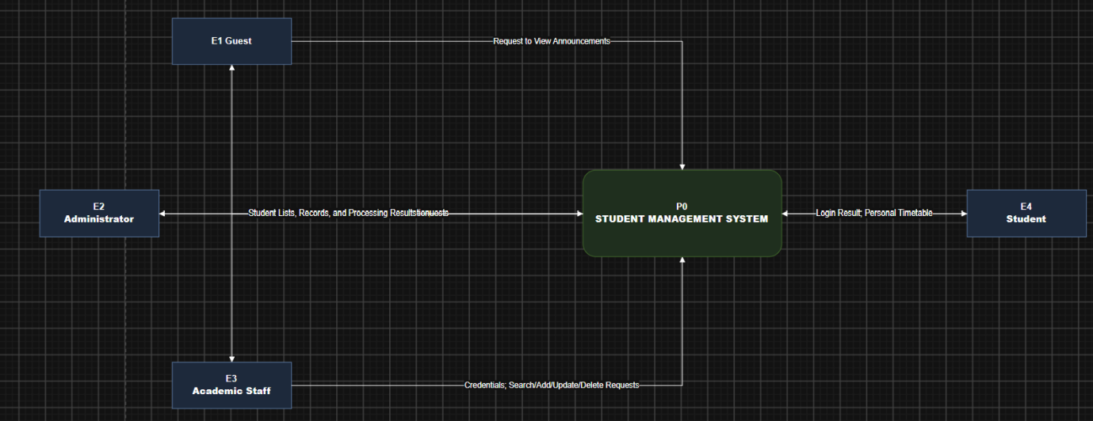
Level 0 DFD

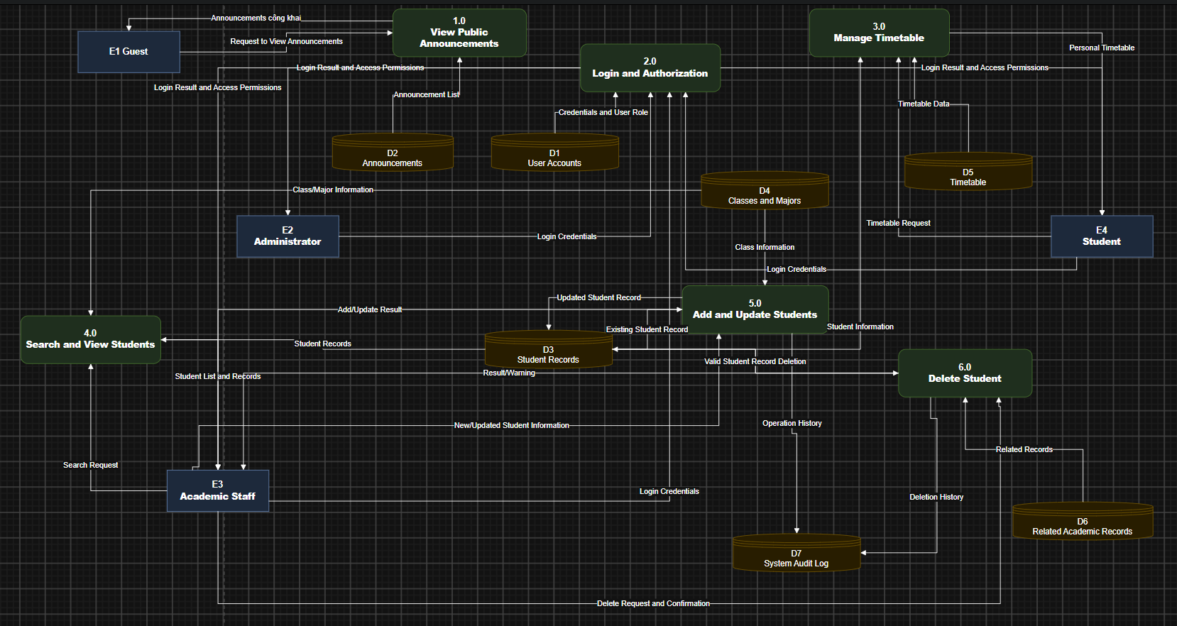
Level 0 DFD

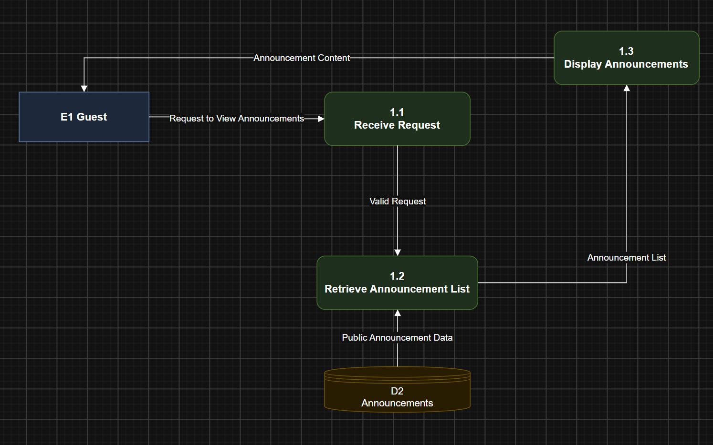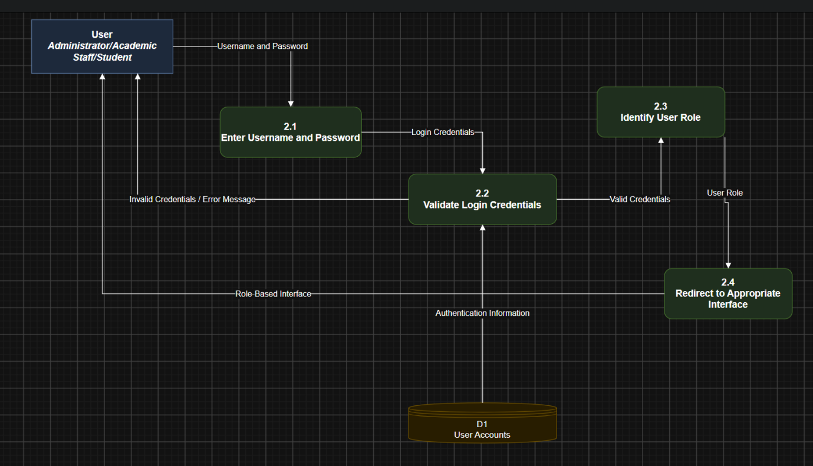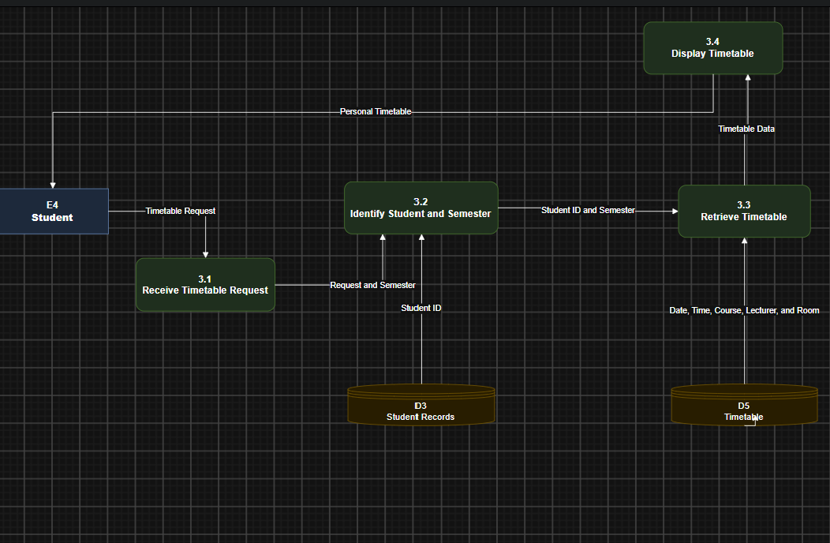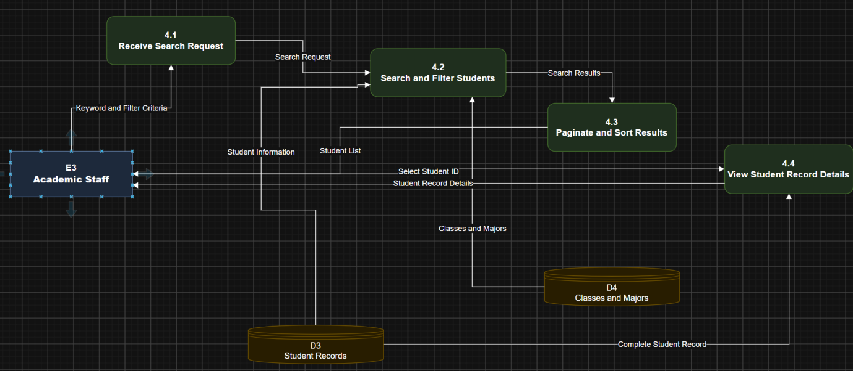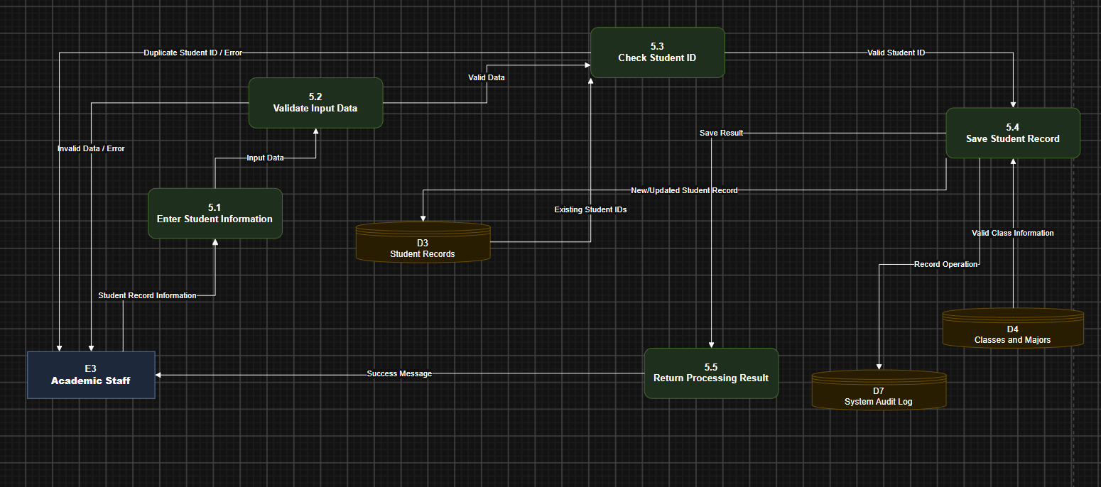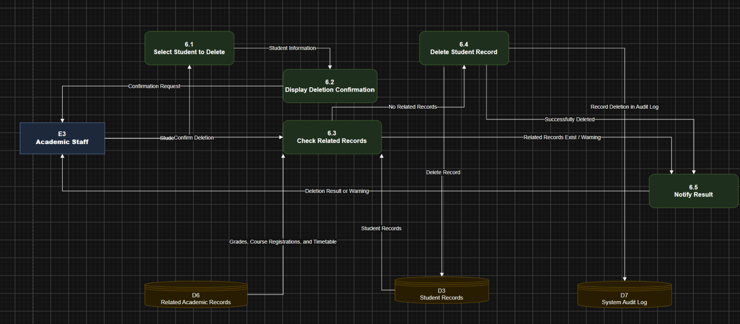

STUDENT MANAGEMENT SYSTEM

1. Context Diagram
Purpose:
The Context Diagram provides an overview of the Student Management System and illustrates the interactions between the system and its external entities.
External Entities:
- Visitor: Requests and views public school announcements without logging in or accessing internal student information.
- Administrator: Logs into the system and receives authentication results and access permissions.
- Academic Staff: Performs student management operations, including searching, viewing, adding, updating, and deleting student records.
- Student: Logs into the system and requests personal timetable information.
Activity Flow:
- The Visitor sends a request to view public announcements. The system retrieves announcement data and displays the results.
- The Administrator, Academic Staff, and Student submit their usernames and passwords to the system.
- The system validates the login credentials and identifies the user's role.
- Academic Staff sends requests to search, view, add, update, or delete student information. The system processes these requests and returns the corresponding results.
- The Student sends a timetable request. The system identifies the student and selected semester, retrieves the corresponding timetable, and displays it.
Conclusion:
The Context Diagram represents the entire Student Management System as a single process and illustrates the main data exchanges between the system and external entities.

2. Level 0 DFD – Student Management System
Purpose:
The Level 0 DFD decomposes the entire system into its main functional processes and illustrates the interactions between external entities, processes, and data stores.
Main Processes:
Process | Name | Description
1.0 | View Public Announcements | Allows Visitors to view public announcements.
2.0 | Login and Authorization | Validates login credentials and determines user permissions.
3.0 | Manage Timetable | Allows Students to view their personal timetables.
4.0 | Search and View Students | Allows Academic Staff to search and view student records.
5.0 | Add and Update Students | Allows Academic Staff to add and update student information.
6.0 | Delete Student | Allows Academic Staff to delete student records after checking related data.
Data Stores:
- D1 – User Accounts: Stores user account information.
- D2 – Announcements: Stores public announcement information.
- D3 – Student Records: Stores student personal and academic information.
- D4 – Classes and Majors: Stores class and major information.
- D5 – Timetable: Stores timetable information.
- D6 – Related Academic Records: Stores related academic data, including grades, course registrations, and timetable-related records.
- D7 – System Audit Log: Stores system operation logs.
Activity Flow:
- Process 1.0 retrieves public announcements from D2 and returns them to the Visitor.
- Process 2.0 receives login credentials, checks them against D1, identifies the user's role, and returns the authentication result.
- Process 3.0 retrieves timetable information from D5 and displays the personal timetable to the Student.
- Process 4.0 retrieves student information from D3 and D4 to perform searching, filtering, sorting, and displaying student records.
- Process 5.0 validates student information and saves new or updated records to D3. Relevant operations are recorded in D7.
- Process 6.0 checks related academic records in D6 before deleting a student record from D3. Successful deletion operations are recorded in D7.
Conclusion:
The Level 0 DFD provides an overview of the system's main functions and illustrates how data flows between external entities, processing activities, and data stores.

3. Level 1 DFD – View Public Announcements
Purpose:
This diagram decomposes Process 1.0 and describes how the system receives and processes requests to view public announcements.
Sub-processes:
- 1.1 – Receive Request: Receives the announcement request from the Visitor.
- 1.2 – Retrieve Announcement List: Retrieves announcement data from D2 – Announcements.
- 1.3 – Display Announcements: Displays the announcement list to the Visitor.
Activity Flow:
- The Visitor sends a request to view public announcements.
- Process 1.1 receives the request and forwards it to Process 1.2.
- Process 1.2 retrieves announcement information from D2 – Announcements.
- The retrieved announcement list is passed to Process 1.3.
- Process 1.3 processes and displays the announcements to the Visitor.
Conclusion:
This function allows Visitors to access public school announcements without logging into the system. Visitors are not allowed to access internal information or student records.

4. Level 1 DFD – Login and Authorization
Purpose:
This diagram decomposes Process 2.0 and describes the authentication process and role identification for different users.
Sub-processes:
- 2.1 – Enter Username and Password: Receives the user's login credentials.
- 2.2 – Validate Login Credentials: Checks the validity of the submitted credentials.
- 2.3 – Identify User Role: Determines the user's role in the system.
- 2.4 – Redirect to Appropriate Interface: Directs the user to the appropriate interface based on their role.
Activity Flow:
- The Administrator, Academic Staff, or Student enters a username and password.
- Process 2.1 receives the login information and forwards it to Process 2.2.
- Process 2.2 compares the submitted credentials with the information stored in D1 – User Accounts.
- If the credentials are invalid, the system displays an error message and asks the user to try again.
- If the credentials are valid, Process 2.3 identifies the user's role.
- Process 2.4 redirects the user to the appropriate interface according to their assigned permissions.
Conclusion:
The login and authorization function protects system data and ensures that each user can only access functions permitted by their assigned role.

5. Level 1 DFD – Manage Timetable
Purpose:
This diagram decomposes Process 3.0 and describes how Students request and view their personal timetables for a selected semester.
Sub-processes:
- 3.1 – Receive Timetable Request: Receives the timetable request from the Student.
- 3.2 – Identify Student and Semester: Identifies the Student and the selected semester.
- 3.3 – Retrieve Timetable: Retrieves the corresponding timetable information.
- 3.4 – Display Timetable: Displays the timetable to the Student.
Activity Flow:
- The Student logs into the system and submits a request to view their timetable.
- Process 3.1 receives the timetable request.
- Process 3.2 identifies the Student and the selected semester.
- Process 3.3 retrieves timetable information from D5 – Timetable.
- The system retrieves the courses corresponding to the selected Student and semester.
- Process 3.4 displays the timetable to the Student.
Timetable Information Includes:
- Course name and course code.
- Days of the week, from Monday to Sunday.
- Class start time and end time.
- Lecturer information.
- Learning mode.
- Campus, building, and classroom information.
Conclusion:
This function allows Students to easily access their personal timetables and manage their study schedules.

6. Level 1 DFD – Search and View Students
Purpose:
This diagram decomposes Process 4.0 and describes how Academic Staff search, filter, sort, and view detailed student information.
Sub-processes:
- 4.1 – Receive Search Request: Receives the student search request.
- 4.2 – Search and Filter Students: Searches and filters student records.
- 4.3 – Paginate and Sort Results: Organizes search results using pagination and sorting.
- 4.4 – View Student Record Details: Displays detailed student information.
Activity Flow:
- Academic Staff submits a request to search for student information.
- Process 4.1 receives search criteria such as Student ID or full name.
- Process 4.2 retrieves data from D3 – Student Records and D4 – Classes and Majors to perform searching and filtering.
- Academic Staff can filter students by class, major, or study status.
- Process 4.3 sorts the results by Student ID, full name, or date of birth and divides the results into pages.
- The system returns a list of students matching the search criteria.
- When Academic Staff selects a student, Process 4.4 retrieves and displays the student's detailed information.
Conclusion:
This function helps Academic Staff search for and manage student information efficiently, especially when dealing with a large number of student records.

7. Level 1 DFD – Add and Update Students
Purpose:
This diagram decomposes Process 5.0 and describes how Academic Staff add new student records and update existing student information.
Sub-processes:
- 5.1 – Enter Student Information: Receives student information entered by Academic Staff.
- 5.2 – Validate Input Data: Checks the validity and completeness of the submitted information.
- 5.3 – Check Student ID: Checks whether the Student ID already exists.
- 5.4 – Save Student Record: Saves new or updated student information.
- 5.5 – Return Processing Result: Returns the processing result to Academic Staff.
Activity Flow:
- Academic Staff selects the function to add a new student or update an existing student record.
- Process 5.1 receives the student information.
- Process 5.2 checks required fields and validates the submitted data.
- The system checks the email address, phone number, and other required information.
- Process 5.3 checks the Student ID in D3 – Student Records to ensure that the ID is unique when adding a new student.
- If the information is invalid or the Student ID already exists, the system displays an error message and asks Academic Staff to correct the information.
- If all information is valid, Process 5.4 saves the student record to D3.
- For update operations, the system allows student information to be modified, but the Student ID cannot be changed.
- After successfully saving the information, the system records the operation in D7 – System Audit Log.
- Process 5.5 returns the processing result to Academic Staff.
Student Information Includes:
- Student ID.
- Full name.
- Date of birth.
- Gender.
- Class.
- Academic cohort.
- Phone number.
- Email address.
- Study status.
Conclusion:
This function ensures that student information is entered and updated accurately, prevents duplicate records, and supports the tracking of data changes.

8. Level 1 DFD – Delete Student
Purpose:
This diagram decomposes Process 6.0 and describes how the system deletes student records after checking related academic data.
Sub-processes:
- 6.1 – Select Student to Delete: Selects the student record to be deleted.
- 6.2 – Display Deletion Confirmation: Displays a confirmation request before deletion.
- 6.3 – Check Related Records: Checks whether related academic records exist.
- 6.4 – Delete Student Record: Deletes the student record if all conditions are satisfied.
- 6.5 – Notify Result: Returns the deletion result to Academic Staff.
Activity Flow:
- Academic Staff searches for and selects the student record to be deleted.
- Process 6.1 receives the selected student information.
- Process 6.2 displays a confirmation message to prevent accidental deletion.
- If Academic Staff does not confirm the deletion, the system cancels the operation.
- If Academic Staff confirms the deletion, Process 6.3 checks related records in D6 – Related Academic Records.
- The system checks whether the student has existing grades, course registrations, or related timetable records.
- If related records exist, the system refuses the deletion and displays a warning message.
- If no related records exist, Process 6.4 deletes the student record from D3 – Student Records.
- After successful deletion, the system records the operation in D7 – System Audit Log.
- Process 6.5 returns the deletion result to Academic Staff.
Conclusion:
This function ensures data integrity, prevents the loss of important academic information, and reduces the risk of accidental student record deletion.

9. Overall System Evaluation
The Student Management System consists of six main functional groups:
Function | User | Output
View Public Announcements | Visitor | Public announcement list
Login and Authorization | Administrator, Academic Staff, Student | Authentication result and access permissions
Manage Timetable | Student | Personal timetable
Search and View Students | Academic Staff | Student list and detailed records
Add and Update Students | Academic Staff | New or updated student records
Delete Student | Academic Staff | Deletion result
Overall Evaluation:
The DFD diagrams describe the system's data processing activities from a general perspective to detailed functional processes.
The Context Diagram illustrates the system boundary and interactions with external entities. The Level 0 DFD presents the main functional processes and data stores. The Level 1 DFDs provide detailed descriptions of the data flows within each main process.
These diagrams help improve system understanding, support database design, and provide a foundation for the implementation phase.
Note: Non-functional requirements such as response time, concurrent users, password security, automatic logout, and data backup are system quality constraints. They should be documented separately rather than represented as independent DFD processes.

Usecase
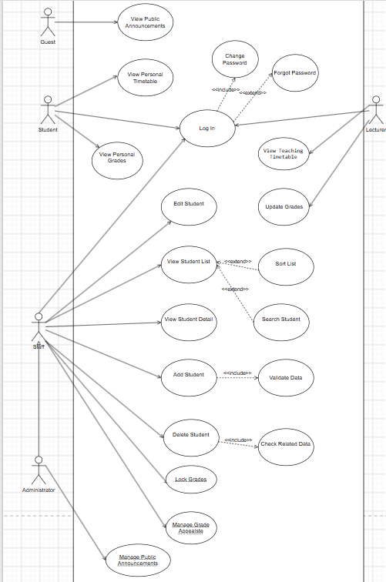
1.DANH SÁCH CÁC ACTOR
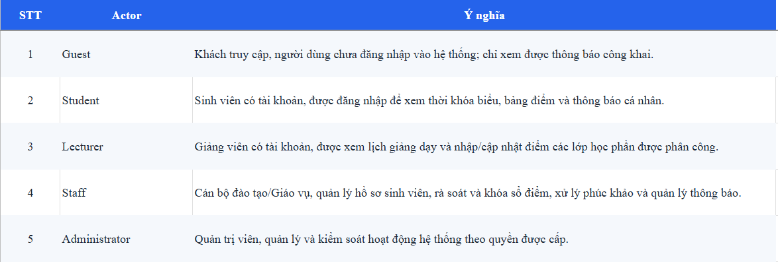
2. DANH SÁCH CÁC USE CASE
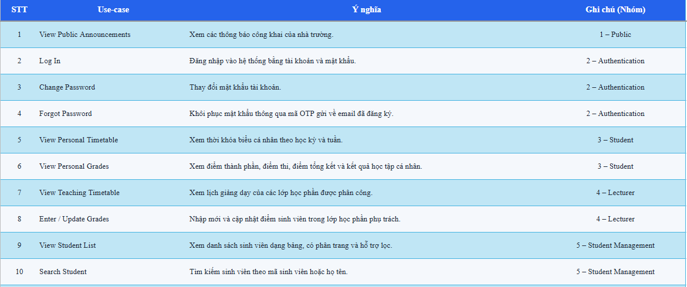

2.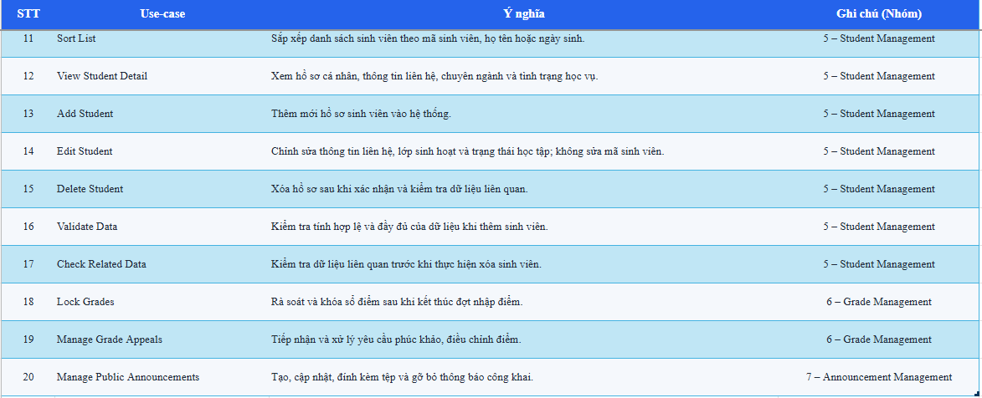 3. DETAILED USE CASE SPECIFICATIONS

01 – View Public Announcements

Primary Actor: Guest

Brief Description:

This use case allows guests to view public announcements published by the school without logging in.

Preconditions:

The system is available.

Public announcements have been published.

Main Flow:

The guest accesses the Student Management System.

The system displays the homepage.

The guest selects the public announcements section.

The system retrieves the published announcements.

The system displays the announcements.

The guest selects an announcement to view its details.

The system displays the selected announcement.

Alternative Flows:

4a. No announcements are available.

The system displays a message indicating that there are currently no announcements.

Postconditions:

The guest has successfully viewed the available public announcements.

No login session is created.

02 – View Personal Timetable

Primary Actor: Student

Brief Description:

This use case allows students to view their personal class timetable by semester.

Preconditions:

The student has successfully logged in.

The student has an available timetable.

Main Flow:

The student selects the View Personal Timetable function.

The system displays the timetable interface.

The student selects a semester.

The system retrieves the student's timetable.

The system displays the weekly timetable from Monday to Sunday.

The timetable displays the following information:

Subject name.

Course code.

Lecturer name.

Learning mode (online or in-person).

Campus or building.

Classroom.

Class time.

Alternative Flows:

4a. No timetable is available for the selected semester.

The system displays a notification indicating that no timetable is available.

Postconditions:

The student has viewed their personal timetable.

03 – Change Password

Primary Actor: Student, Lecturer, Staff

Brief Description:

This use case allows an authenticated user to change their current account password.

Preconditions:

The user has successfully logged in.

The user is accessing their account.

Main Flow:

The user opens the account settings.

The user selects the Change Password function.

The system displays the password change form.

The user enters the current password.

The user enters a new password.

The user confirms the new password.

The system validates the submitted information.

The system updates the user's password.

The system displays a success notification.

Alternative Flows:

7a. The current password is incorrect.

The system displays an error message.

7b. The new password and confirmation do not match.

The system requests the user to enter the password again.

7c. The new password does not satisfy the password requirements.

The system displays the validation error.

Postconditions:

The user's password is successfully updated.

04 – Forgot Password

Primary Actor: Student, Lecturer, Staff

Brief Description:

This use case allows users who have forgotten their passwords to recover access to their accounts through email verification.

Preconditions:

The user has an existing account.

The account is associated with a valid email address.

Main Flow:

The user opens the login page.

The user selects the Forgot Password function.

The system displays the password recovery form.

The user enters their registered email address.

The system checks the email address.

The system sends a verification code to the registered email.

The user enters the verification code.

The system verifies the code.

The user enters a new password.

The user confirms the new password.

The system updates the password.

The system displays a success notification.

Alternative Flows:

5a. The email address is not registered.

The system displays an appropriate error message.

6a. The verification email cannot be sent.

The system informs the user that the request could not be completed.

8a. The verification code is incorrect or expired.

The system asks the user to request or enter a valid code.

10a. The new password and confirmation do not match.

The system requests the user to enter the password again.

Postconditions:

The user's password is updated after successful verification.

05 – Log In

Primary Actor: Student, Lecturer, Staff

Brief Description:

This use case allows registered users to access the system by providing valid login credentials.

Preconditions:

The user has an account.

The system is available.

Main Flow:

The user opens the login page.

The system displays the login form.

The user enters a username and password.

The user submits the login information.

The system validates the credentials.

The system identifies the user's role.

The system redirects the user to the appropriate interface.

The user successfully accesses the system.

Alternative Flows:

5a. The username or password is incorrect.

The system displays an error message.

The user can enter the credentials again.

5b. The account does not exist.

The system displays an appropriate error message.

Postconditions:

A valid user session is created.

The user is redirected to the interface corresponding to their role.

06 – View Personal Grades

Primary Actor: Student

Brief Description:

This use case allows students to view their own academic grades and semester results.

Preconditions:

The student has successfully logged in.

Academic grades are available in the system.

Main Flow:

The student selects the View Personal Grades function.

The system retrieves the student's academic records.

The system displays the student's grade information.

The student selects a semester if necessary.

The system displays the relevant grade details, including:

Grade components.

Examination scores.

Semester GPA.

Alternative Flows:

2a. No grades are available.

The system displays a notification indicating that no grade information is available.

Postconditions:

The student has viewed their personal academic results.

The student cannot modify their grades.

07 – View Teaching Timetable

Primary Actor: Lecturer

Brief Description:

This use case allows lecturers to view their personal teaching timetable, including assigned courses, class schedules, and classroom information.

Preconditions:

The lecturer has successfully logged in.

The lecturer has an assigned teaching timetable.

Main Flow:

The lecturer selects the View Teaching Timetable function.

The system displays the teaching timetable interface.

The lecturer selects a semester or week.

The system retrieves the lecturer's assigned teaching schedule.

The system displays the timetable.

The timetable includes:

Course name.

Course code.

Class time.

Classroom.

Campus or building.

Learning mode.

Alternative Flows:

4a. No teaching timetable is available.

The system displays a notification indicating that no teaching schedule is available.

4b. The selected semester has no scheduled classes.

The system displays an empty timetable.

Postconditions:

The lecturer has successfully viewed their teaching timetable.

08 – Edit Student

Primary Actor: Staff

Brief Description:

This use case allows staff to update existing student information.

Preconditions:

Staff has successfully logged in.

The selected student record exists.

Main Flow:

Staff selects the Edit Student function.

The system displays the student information.

Staff selects the information to update.

Staff modifies the permitted fields, such as:

Class.

Contact information.

Academic status.

Staff submits the changes.

The system validates the updated information.

The system saves the changes.

The system displays a success notification.

Alternative Flows:

6a. The updated information is invalid.

The system displays an error message.

Staff must correct the information.

7a. The system cannot save the changes.

The system displays an error notification.

Postconditions:

The student information is successfully updated.

The student ID remains unchanged.

09 – Update Grades

Primary Actor: Lecturer

Brief Description:

This use case allows lecturers to update student grades for the courses assigned to them.

Preconditions:

The lecturer has successfully logged in.

The lecturer has permission to update grades.

The relevant course section exists.

The grade records are not locked.

Main Flow:

The lecturer selects the Update Grades function.

The system displays the lecturer's assigned course sections.

The lecturer selects a course section.

The system retrieves the students enrolled in that section.

The system displays the student list and existing grades.

The lecturer selects a student.

The lecturer enters or updates the student's grade components.

The lecturer submits the changes.

The system validates the submitted grade information.

The system saves the updated grades.

The system displays a success notification.

Alternative Flows:

4a. No students are enrolled in the selected course section.

The system displays an appropriate notification.

9a. The submitted grade information is invalid.

The system displays an error message and requests correction.

9b. The grade records have been locked.

The system refuses the update and informs the lecturer that the grades cannot be modified.

10a. The system cannot save the changes.

The system displays an error notification.

Postconditions:

The student's grade information is successfully updated if the operation is permitted.

10 – View Student List

Primary Actor: Staff

Brief Description:

This use case allows staff to view the list of students stored in the system.

Preconditions:

Staff has successfully logged in.

Student records are available.

Main Flow:

Staff selects the View Student List function.

The system retrieves student records.

The system displays the student list in a table.

The table displays:

Student ID.

Full name.

Date of birth.

Gender.

Class.

Academic status.

The system displays pagination controls if the list contains multiple pages.

Staff views the student information.

Alternative Flows:

2a. No student records are available.

The system displays a notification indicating that the list is empty.

Postconditions:

The student list is displayed successfully.

Extension Points:

Sort List (UC11).

Search Student (UC12).

11 – Sort List

Primary Actor: Staff

Brief Description:

This use case allows staff to sort the student list according to selected information.

Preconditions:

Staff has successfully logged in.

The student list is displayed.

Main Flow:

Staff selects a sorting option.

The system displays the available sorting criteria.

Staff selects a sorting criterion:

Student ID.

Full name.

Date of birth.

Staff selects ascending or descending order.

The system sorts the student records.

The system displays the sorted student list.

Alternative Flows:

5a. The system cannot perform the sorting operation.

The system displays an error notification.

Postconditions:

The student list is displayed according to the selected sorting criteria.

12 – Search Student

Primary Actor: Staff

Brief Description:

This use case allows staff to search for student records using a student ID or full name.

Preconditions:

Staff has successfully logged in.

The student list is available.

Main Flow:

Staff selects the Search Student function.

The system displays the search field.

Staff enters a student ID or full name.

Staff submits the search request.

The system searches the student records.

The system displays the matching results.

Alternative Flows:

5a. No matching student is found.

The system displays a message indicating that no results were found.

3a. The search field is empty.

The system requests staff to enter a search keyword.

Postconditions:

The matching student records are displayed, if available.

13 – View Student Detail

Primary Actor: Staff

Brief Description:

This use case allows staff to view the complete information of a selected student.

Preconditions:

Staff has successfully logged in.

The selected student record exists.

Main Flow:

Staff opens the student list.

Staff selects a student record.

Staff selects the View Student Detail function.

The system retrieves the student's complete information.

The system displays the student profile, including:

Student ID.

Full name.

Date of birth.

Gender.

Contact information.

Class.

Major.

Cohort.

Academic status.

Alternative Flows:

4a. The selected student record cannot be found.

The system displays an error notification.

Postconditions:

Staff has successfully viewed the student's detailed information.

14 – Add Student

Primary Actor: Staff

Brief Description:

This use case allows staff to create a new student record in the system.

Preconditions:

Staff has successfully logged in.

Staff has permission to add student records.

Main Flow:

Staff selects the Add Student function.

The system displays the student registration form.

Staff enters the required information:

Student ID.

Full name.

Date of birth.

Gender.

Class.

Cohort.

Phone number.

Email address.

Academic status.

Staff submits the information.

The system performs data validation.

The system checks whether the student ID already exists.

The system saves the new student record.

The system displays a success notification.

Alternative Flows:

5a. One or more required fields are missing.

The system requests staff to complete the missing fields.

5b. The email address has an invalid format.

The system displays an email validation error.

5c. The phone number does not contain exactly 10 digits.

The system displays a phone number validation error.

6a. The student ID already exists.

The system rejects the new record and displays an error message.

Postconditions:

A new student record is successfully created.

Included Use Case:

Validate Data (UC15).

15 – Validate Data

Primary Actor: Staff

Brief Description:

This use case checks whether the student information entered by staff satisfies the system's validation requirements.

Preconditions:

Staff has entered student information.

The Add Student function has been submitted.

Main Flow:

The system receives the student information.

The system checks whether all required fields are completed.

The system validates the email address format.

The system checks whether the phone number contains exactly 10 digits.

The system checks whether the student ID is unique.

The system returns the validation result.

If all information is valid, the system allows the student record to be saved.

Alternative Flows:

2a. Required information is missing.

The system identifies the missing fields.

3a. The email address format is invalid.

The system reports the invalid email address.

4a. The phone number is invalid.

The system reports the incorrect phone number.

5a. The student ID already exists.

The system reports that the student ID must be unique.

Postconditions:

The system determines whether the submitted student information is valid.

Invalid information is not saved.

16 – Delete Student

Primary Actor: Staff

Brief Description:

This use case allows staff to delete a student record after checking for related academic data and receiving confirmation.

Preconditions:

Staff has successfully logged in.

The selected student record exists.

Main Flow:

Staff selects the Delete Student function.

The system identifies the selected student record.

The system checks whether the student has related data.

If no related data exists, the system displays a deletion confirmation message.

Staff confirms the deletion.

The system deletes the student record.

The system displays a success notification.

The system refreshes the student list.

Alternative Flows:

3a. The student has related data, such as grades, enrolled courses, or timetable records.

The system refuses the deletion.

The system displays a message explaining that the student cannot be deleted because related data exists.

5a. Staff cancels the deletion.

The system stops the deletion process.

The student record remains unchanged.

Postconditions:

If the deletion is confirmed and permitted, the student record is removed.

If deletion is refused or cancelled, the student record remains unchanged.

Included Use Case:

Check Related Data (UC17).

17 – Check Related Data

Primary Actor: Staff

Brief Description:

This use case checks whether a student has related academic records before the system allows the student record to be deleted.

Preconditions:

Staff has initiated the Delete Student function.

The selected student record exists.

Main Flow:

The system receives the student record selected for deletion.

The system checks the student's related records.

The system checks whether the student has:

Grade records.

Enrolled courses.

Timetable records.

The system determines whether related data exists.

If no related data exists, the system allows the deletion process to continue.

If related data exists, the system refuses the deletion.

Alternative Flows:

4a. The system cannot retrieve related data.

The system displays an error message.

The deletion process is stopped.

Postconditions:

The system determines whether the selected student record can be deleted.

18 – Lock Grades

Primary Actor: Staff

Brief Description:

This use case allows staff to lock grade records after the grade entry or adjustment process has been completed. Locked grades cannot be modified through the normal grade update function.

Preconditions:

Staff has successfully logged in.

Staff has permission to lock grade records.

The relevant course section or grade records exist.

Main Flow:

Staff selects the Lock Grades function.

The system displays the available course sections and grade records.

Staff selects the course section or grade records to lock.

The system displays the selected grade information.

Staff confirms the locking operation.

The system changes the grade status to locked.

The system prevents further grade modifications through the normal update function.

The system displays a success notification.

Alternative Flows:

3a. No grade records are available.

The system displays a notification.

5a. Staff cancels the operation.

The system stops the locking process.

The grade records remain unchanged.

6a. The system cannot lock the grade records.

The system displays an error notification.

Postconditions:

The selected grade records are locked if the operation is successful.

Locked grade records cannot be modified through the normal grade update function.

19 – Manage Grade Appeals

Primary Actor: Staff

Brief Description:

This use case allows staff to manage student requests for grade appeals and review their processing status.

Preconditions:

Staff has successfully logged in.

Staff has permission to manage grade appeals.

Grade appeal requests are available in the system.

Main Flow:

Staff selects the Manage Grade Appeals function.

The system retrieves the available grade appeal requests.

The system displays the list of appeal requests.

Staff selects a specific appeal request.

The system displays the appeal details, including:

Student information.

Course information.

Current grade.

Appeal reason.

Submission date.

Appeal status.

Staff reviews the appeal request.

Staff updates the appeal status or records the processing result.

Staff saves the changes.

The system updates the appeal information.

The system displays a success notification.

Alternative Flows:

2a. No grade appeal requests are available.

The system displays a notification indicating that there are no pending requests.

4a. The selected appeal request cannot be found.

The system displays an error notification.

7a. The appeal information is invalid or incomplete.

The system requests staff to correct the information.

8a. The system cannot save the changes.

The system displays an error notification.

Postconditions:

The grade appeal request is successfully processed or its status is updated.

20 – Manage Public Announcements

Primary Actor: Staff

Brief Description:

This use case allows staff to create, update, view, and delete public announcements displayed on the Student Management System.

Preconditions:

Staff has successfully logged in.

Staff has permission to manage public announcements.

Main Flow:

Staff selects the Manage Public Announcements function.

The system displays the list of existing announcements.

Staff selects an operation:

Create a new announcement.

Update an existing announcement.

Delete an announcement.

If creating an announcement, staff enters the announcement title and content.

If updating an announcement, staff selects an existing announcement and modifies its information.

If deleting an announcement, staff selects the announcement and confirms the deletion.

The system validates the submitted information or deletion request.

The system saves the changes or deletes the selected announcement.

The system displays a success notification.

Alternative Flows:

3a. No announcements are available.

The system displays an empty announcement list.

4a. Required announcement information is missing.

The system requests staff to complete the required fields.

7a. The submitted information is invalid.

The system displays an error message and requests correction.

6a. Staff cancels the deletion.

The system stops the deletion process.

The announcement remains unchanged.

8a. The system cannot save or delete the announcement.

The system displays an error notification.

Postconditions:

The announcement is successfully created, updated, or deleted.

Published public announcements can be viewed by guests.

4. USE CASE RELATIONSHIPS

4.1. Actor Generalization

Administrator is a specialized actor of Staff.

Administrator inherits the use cases associated with Staff.

4.2. Include Relationships
Base Use Case | Included Use Case | Description
Add Student (UC14) | Validate Data (UC15) | Student information must be validated before it is saved.
Delete Student (UC16) | Check Related Data (UC17) | The system must check related academic records before deleting a student.

4.3. Extend Relationships
Base Use Case | Extending Use Case | Description
View Student List (UC10) | Sort List (UC11) | Staff can optionally sort the displayed student list.
View Student List (UC10) | Search Student (UC12) | Staff can optionally search for a student.

4.4. Authentication Relationships

Log In (UC05) is required before accessing protected functions such as View Personal Timetable (UC02), View Personal Grades (UC06), View Teaching Timetable (UC07), and other role-based functions.

Change Password (UC03) is an account-related function available to authenticated users.

Forgot Password (UC04) provides an account recovery process for users who cannot remember their passwords.

Class diagram
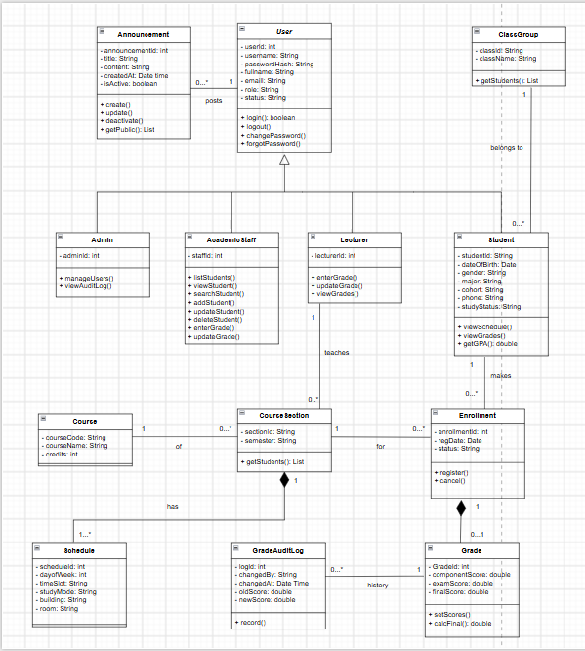

Data model

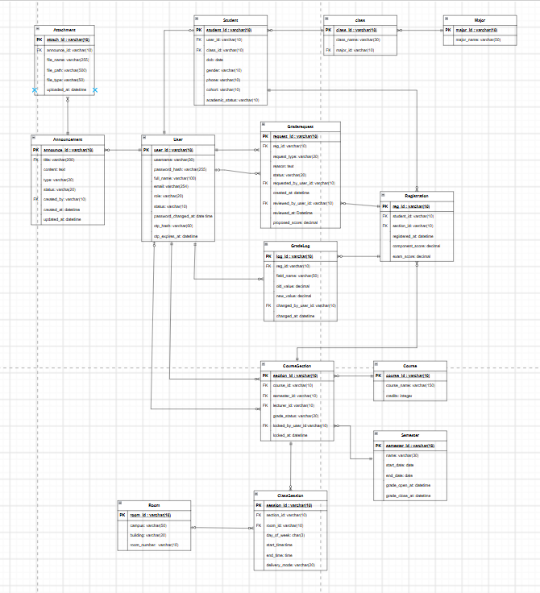

Design
overall interface
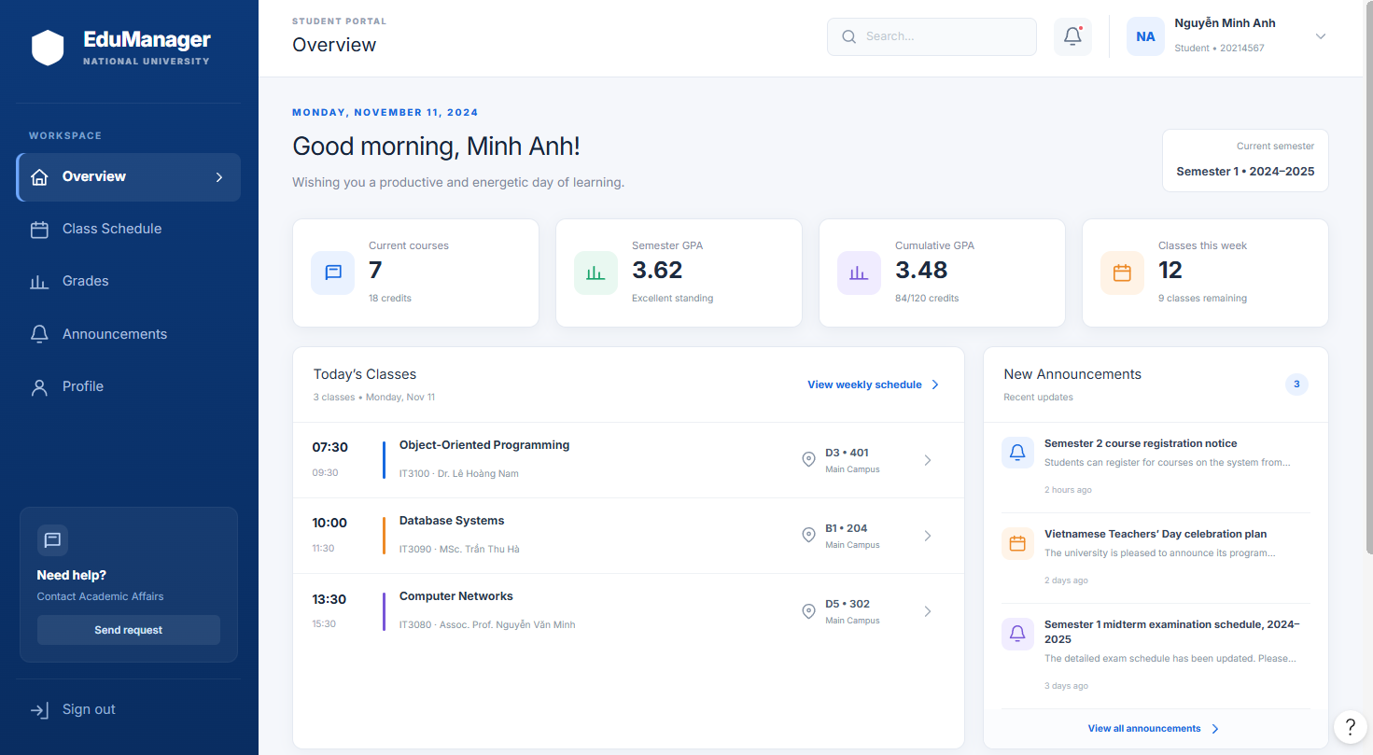

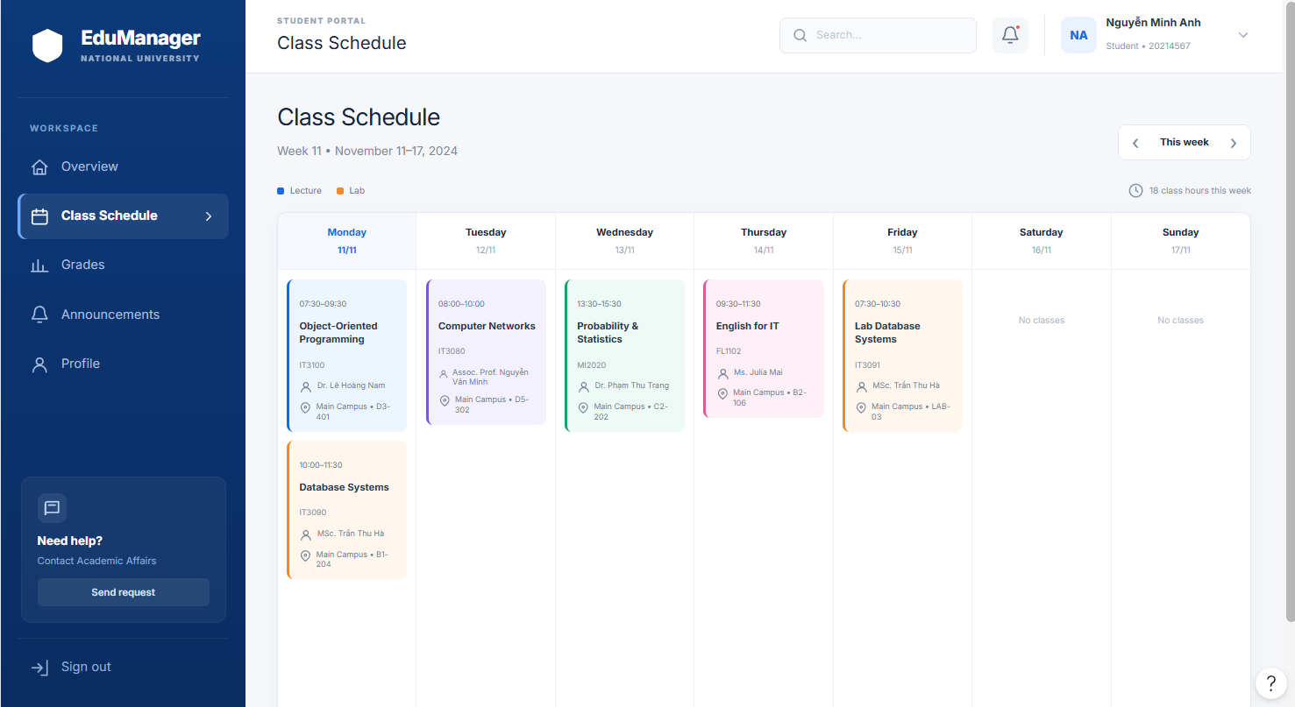
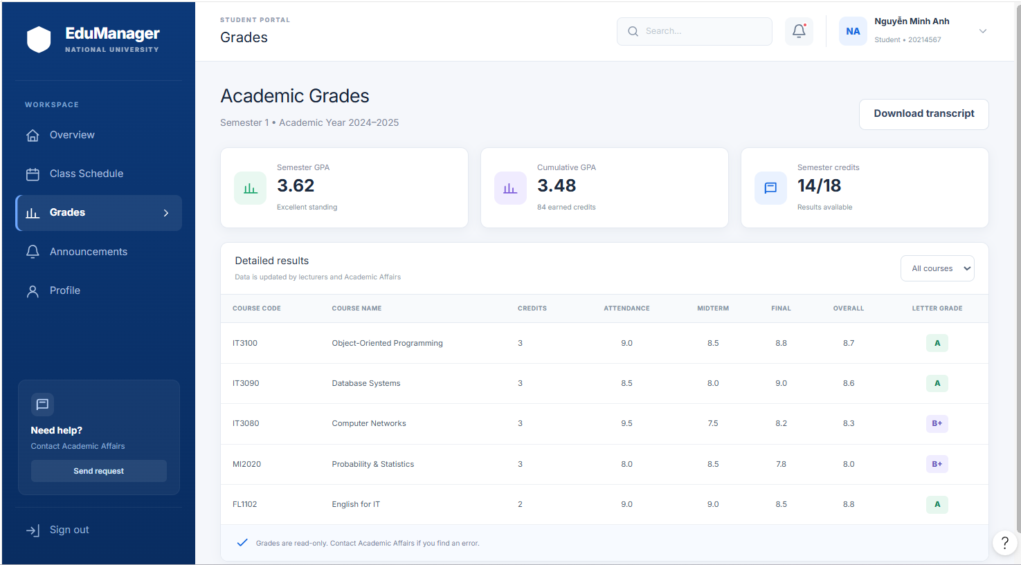
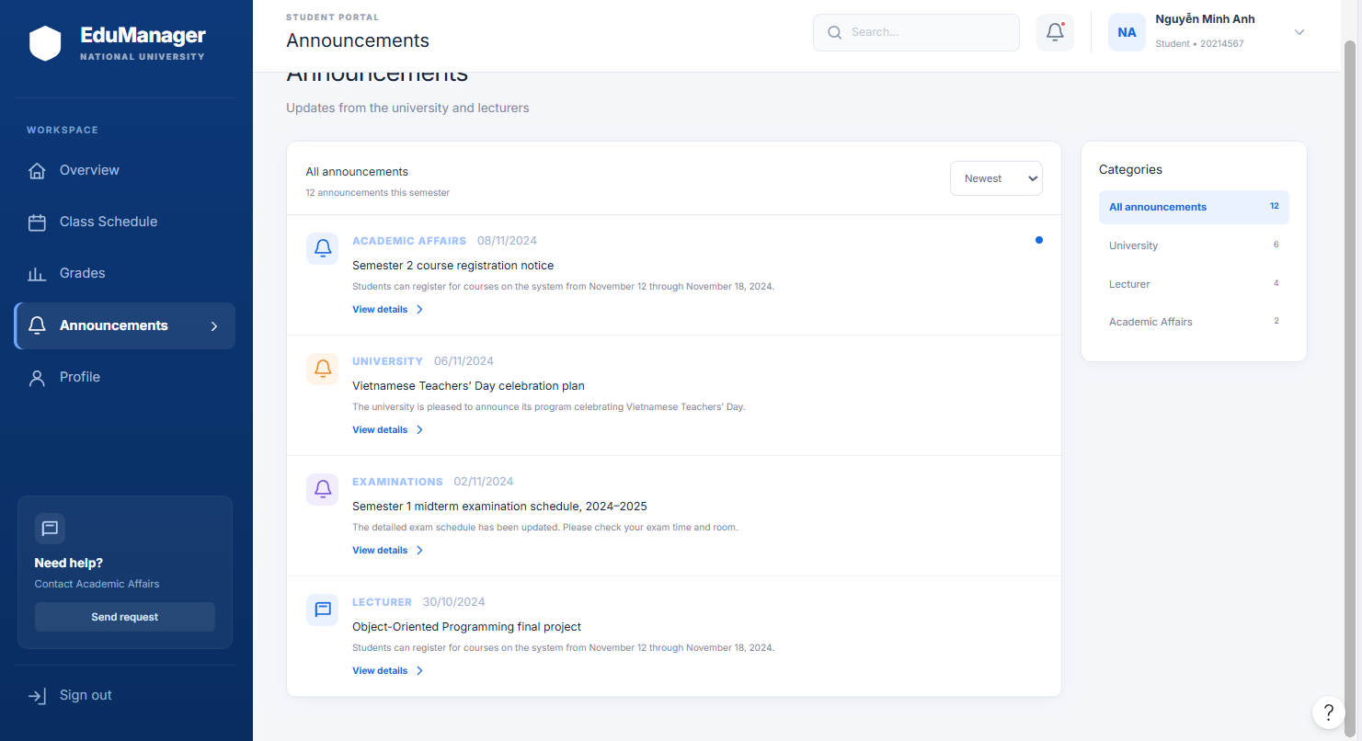
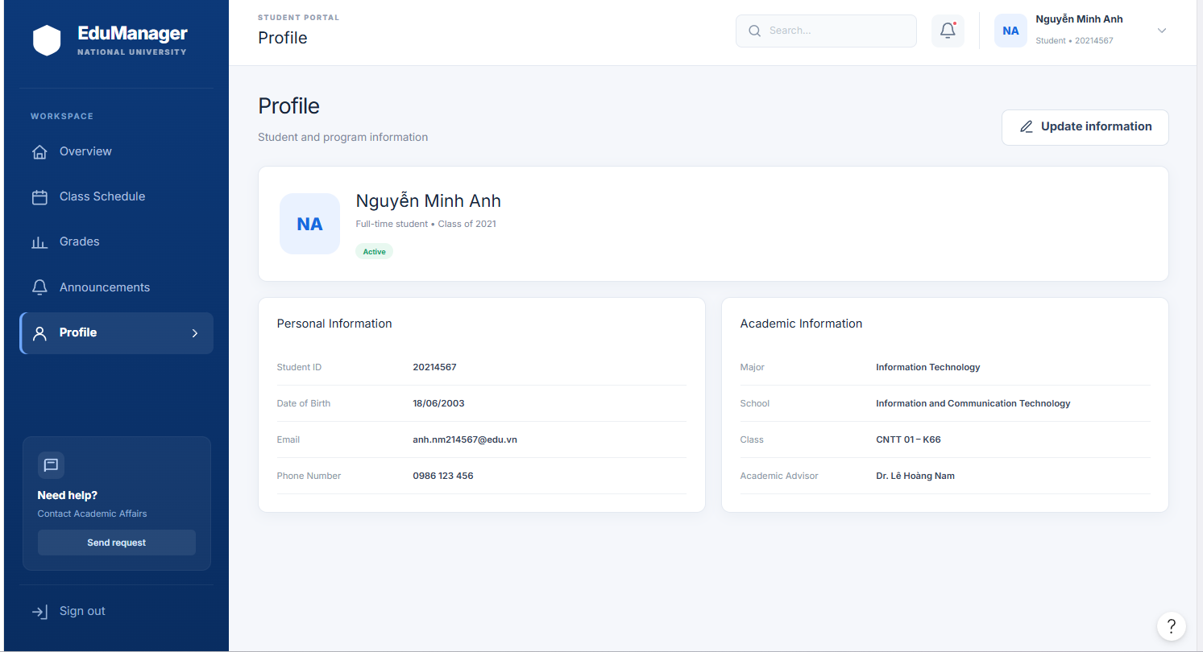

lecturer


